WebSocketSDK(PHP) Sample for Windows
(M50, M60, M70)
2023/3/30
- System Requerements
Item | Supported | Tested
OS | Win7 / Windows 2012 Server, or Later | Win10
IIS | IIS 8, or Later | IIS 8, IIS 10
Internet Explorer | IE10, IE11 | IE11
PHP | PHP7 or Later | PHP8
M50, M60, M70 FW | v2.2.6 20151027 or Later | v2.2.9

- Server Configuration
PHP webserver can be configured in various way, and there are many integrated PHP webserver applications such as XAMPP, WAMP, etc.
Developers can install any PHP webserver which they prefer, but in this document we only use PHP8 from PHP Web site and it’s embedded web server.
- Install PHP
Download latest version of PHP from PHP Web site.
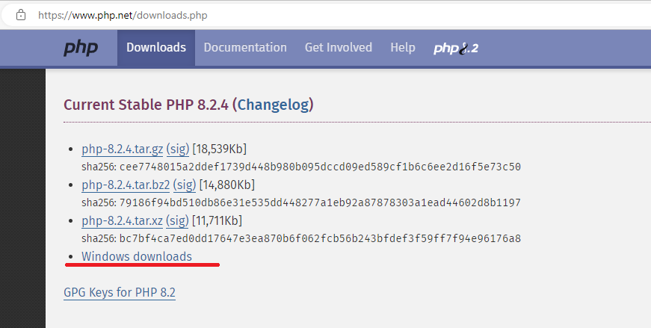
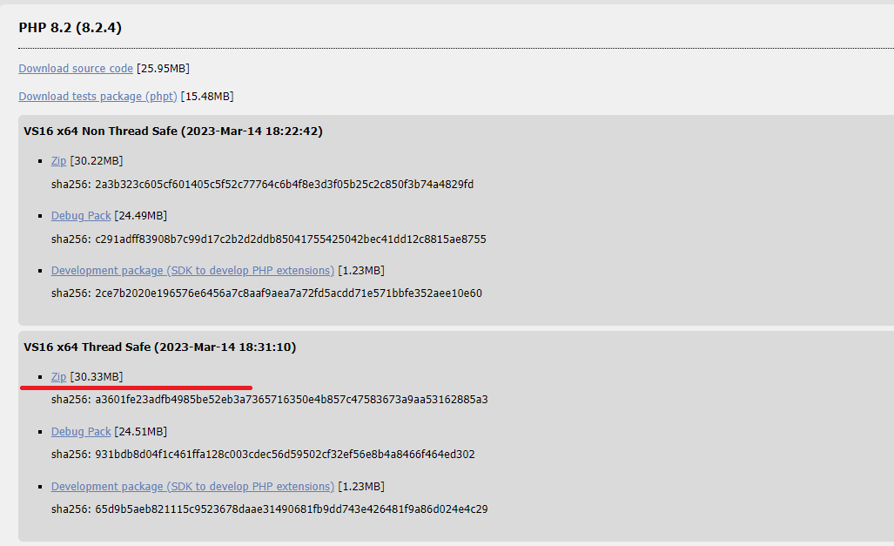

Extract PHP to certain directory(Ex: C:\PHP)
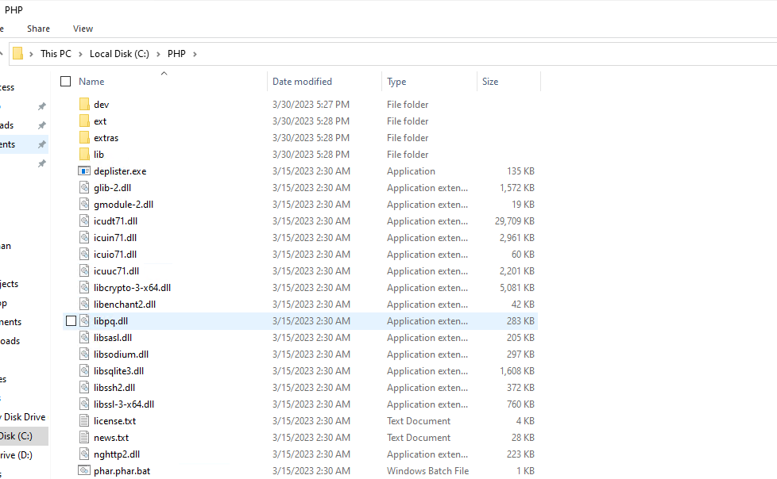

Rename php.ini-development or php.ini-production to php.ini, and open php.ini with notepad.
Set extension directory and enable following extensions.
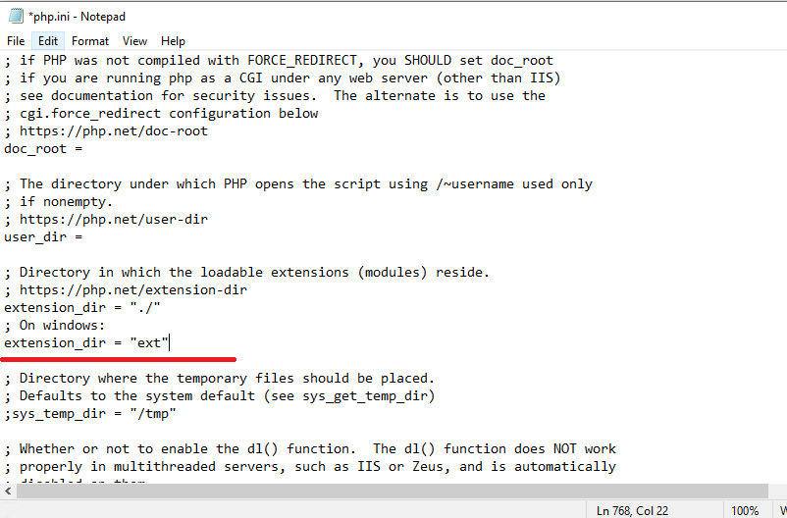
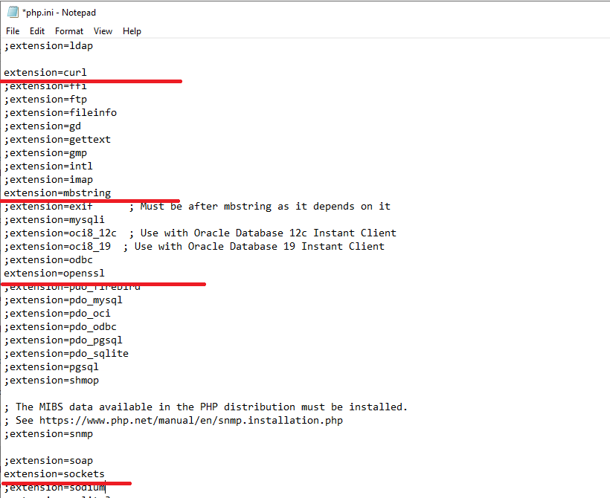

Add PHP installation directory to system PATH variable.
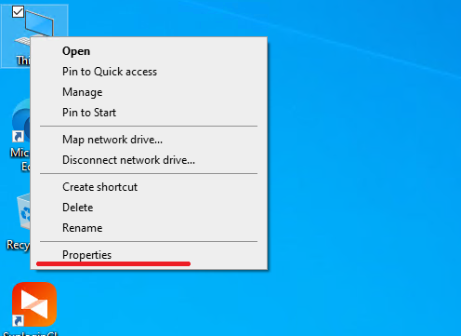
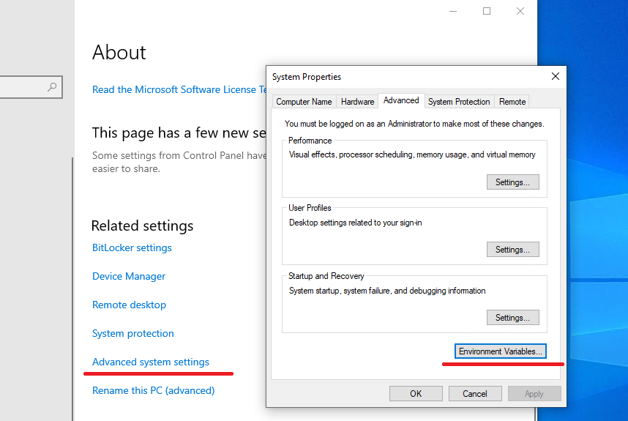
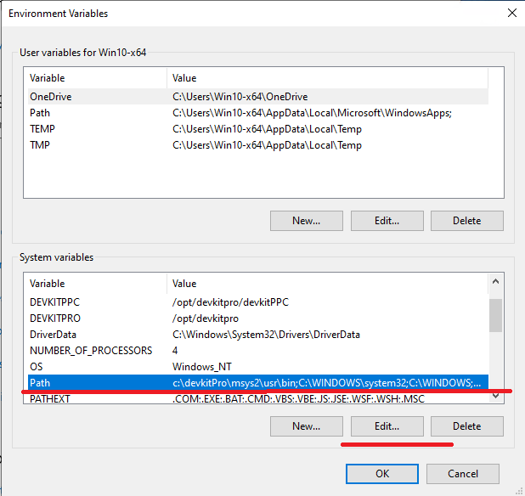
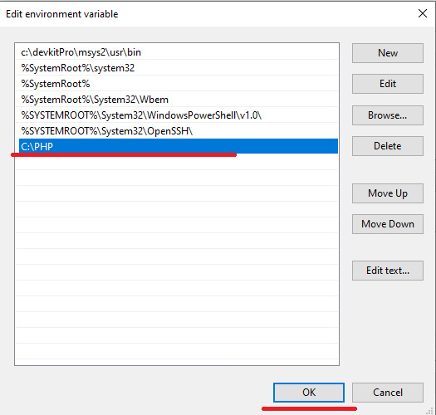
NOTE: After setting system environment variable, please reboot your computer to make it work.

NOTE: If visual studio 2017 or later version is not installed on your computer, please download visual studio redistributable package from Latest supported Visual C++ Redistributable downloads | Microsoft Learn and install it.
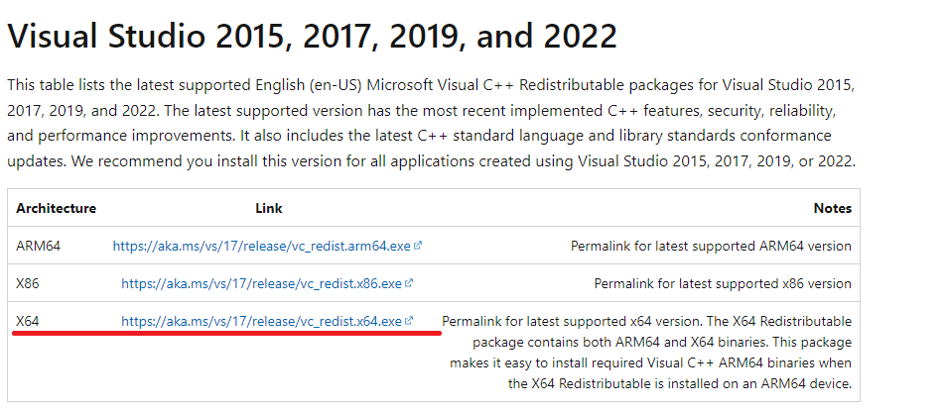

Open command prompt and to check if PHP is successfully installed on your computer.
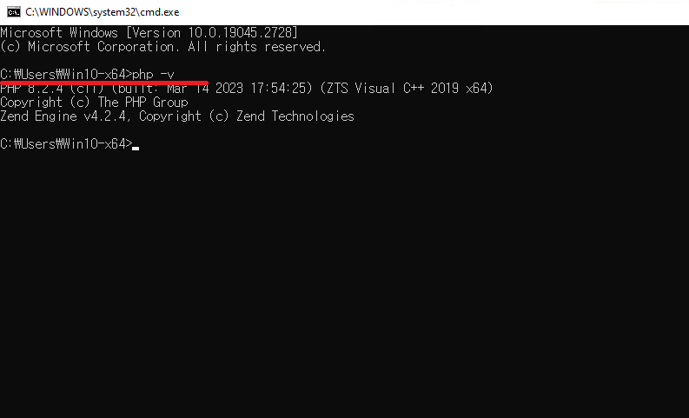

- Install PHP Composer
Install PHP composer as described in https://www.geeksforgeeks.org/how-to-install-php-composer-on-windows/.

- Sample Configuration and run server
- Download workerman package.
Open windows command prompt and move to WebSocketSDK_PHP directory and run following command.
composer require walkor/workerman
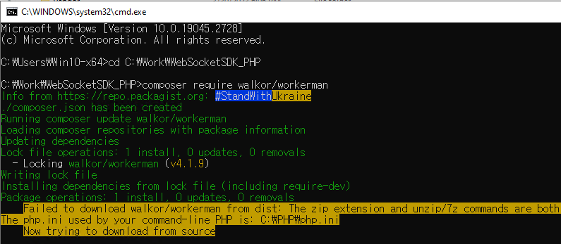
NOTE: To install workerman package you need to install Git first.
Git can be downloaded from Git - Downloads (git-scm.com).

- Set websocket server port.
Open WebSocketSDK_PHP/ config.inc.php file and set websocket server port.
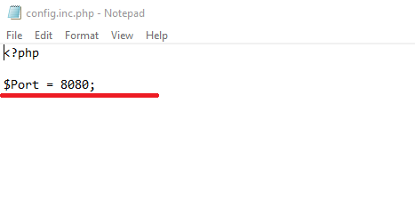

- Run PHP websocket server.
Open command prompt and move to WebSocketSDK_PHP directory and run following command.
php ws_server.php
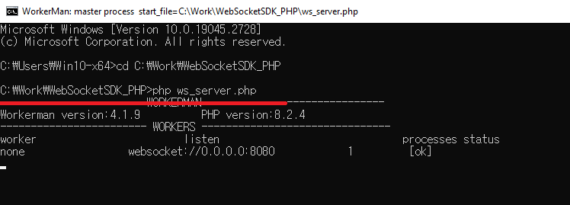

- Run PHP web server.
Open command prompt and move to WebSocketSDK_PHP /wwwroot directory and run following command.
php -S 0.0.0.0:[PORT]
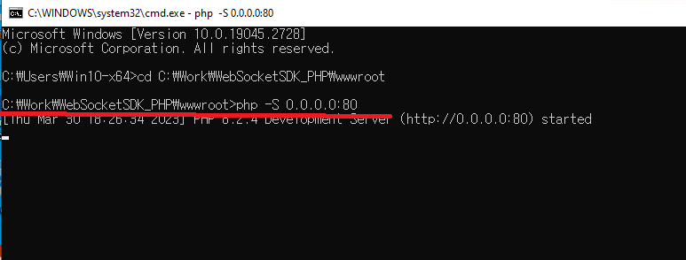

- Prepare Firmware
- Set Active Client Mode.
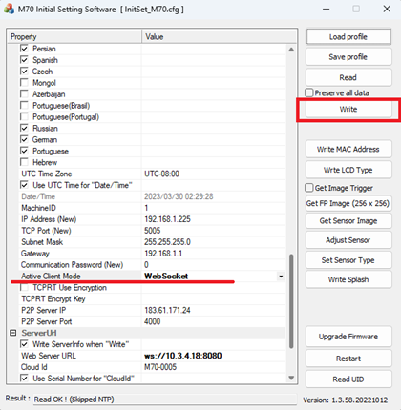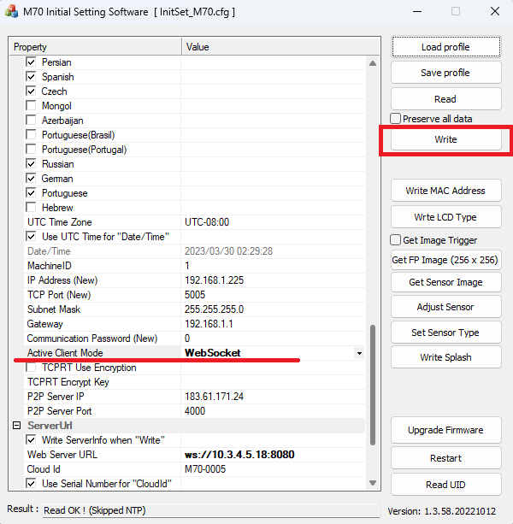
- Set Device Serial Number
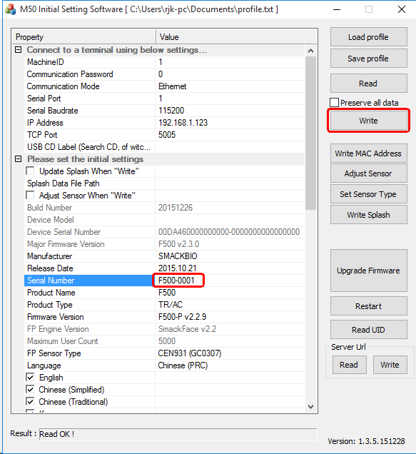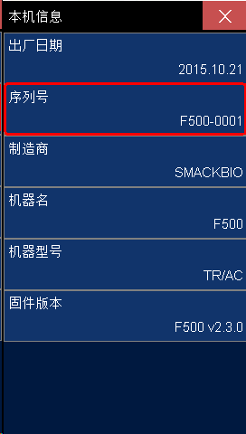
- Set WebServer Address.
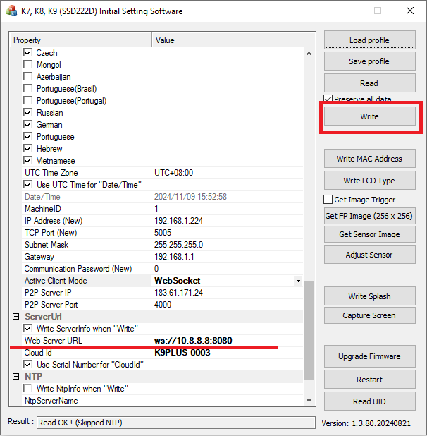
- Restart the terminal.
- Open your web browser and open your sample home page http://localhost.

